

Enhancing Stock Price Prediction for Nifty 50 IT Sector Companies: A Comparative Study of ML Models with Event Data Integration

CS6510 – PROJECT 1
REPORT

Submitted by
Aniket Shinde – 24MSP3038

In partial fulfilment for the award of the degree of
POST GRADUATE PROGRAMME
INTERNATIONAL CENTRE FOR HIGHER EDUCATION AND RESEARCH
VIT BANGALORE

DECEMBER, 2023



BONAFIDE CERTIFICATE
Certified that this project report “Enhancing Stock Price Prediction for Nifty 50 IT Sector Companies: A Comparative Study of ML Models with Event Data Integration” is the bonafide record of work done by “Aniket Shinde – 24MSP3038” who carried out the project work under my supervision.

Signature of the Supervisor Signature of Director

Dr. Pitchumani Angayarkanni S  Professor,  ICER  VIT Bangalore | Prof. Prema M  Director,  ICER  VIT Bangalore.
Evaluation Date:



ACKNOWLEDGEMENT

I express my sincere gratitude to our director of ICER Prof. Prema M. for their support and for providing the required facilities for carrying out this study.
I wish to thank my faculty supervisor(s), Dr. Pitchumani Angayarkanni S, Professor, ICER for extending help and encouragement throughout the project. Without his/her continuous guidance and persistent help, this project would not have been a success for me.
I am grateful to all the members of ICER, my beloved parents, and friends for extending the support, who helped us to overcome obstacles in the study.

TABLE OF CONTENTS
CHAPTER NO. | TITLE | PAGE NO.
 | ABSTRACT
 | LIST OF FIGURES
 | INTRODUCTION
 | LITERATURE REVIEW
 | OBJECTIVE
 | PROPOSED METHODOLOGY
 | TOOLS AND TECHNIQUES
 | IMPLEMENTATION
 | RESULTS AND DISCUSSIONS
 | CONCLUSION
 | FUTURE ENHANCEMENT
 | APPENDICES
 | Appendix-1: Code – Full Code
 | Appendix-2: Plagiarism Report
 | REFERENCES
 | WORKLOG

ABSTRACT
This study addresses the challenge of predicting stock prices in the volatile IT sector of the Nifty 50 index, where traditional models based solely on historical data often fail to account for influential market events, such as economic policy shifts, earnings reports, and global economic changes. By incorporating event-driven data into predictive models, this research aims to improve the accuracy of stock price forecasting for IT companies, providing a more responsive tool for market analysis. Specifically, we evaluate the performance of ARIMA, SARIMA, GRU, and LSTM models, integrating event-driven and sentiment-based features through feature selection to identify the most impactful variables. The comparative analysis of these models across multiple performance metrics highlights the potential of event-enhanced LSTM models, which demonstrate lower error rates and improved accuracy over baseline approaches. The findings contribute to existing financial literature by demonstrating how the integration of external events and feature optimization can significantly improve stock forecasting accuracy. This study holds practical value for investors, analysts, and financial institutions, supporting more robust decision-making in high-volatility markets and setting a foundation for applying this predictive approach across other sectors.

LIST OF FIGURES

Figure No. Figure Name Pg. No.
Fig. 4.1 Methodology 5
Fig. 6.1 Architecture of ResNet50 8
Fig. 6.2 Architecture of VGG16 8
Fig. 6.3 Architecture of InceptionV3 9
Fig. 6.4 Architecture of DenseNET169 9

- INTRODUCTION
The stock market serves as a critical indicator of global economic health, reflecting the performance of industries and the broader financial landscape. Predicting stock prices has long been an area of interest for investors and analysts, as accurate forecasts enable better decision-making, risk management, and investment strategies. However, the stock market’s highly volatile and multifaceted nature makes accurate prediction a significant challenge. External factors such as macroeconomic policies, geopolitical events, and market sentiment intertwine with historical trends, creating a dynamic environment that is difficult to model using traditional methods. This study explores the potential of machine learning to address these challenges and provide a more robust framework for forecasting stock prices.
Historically, stock market analysis has relied on statistical techniques that assume linear relationships in the data. While these methods offer valuable insights, they often fail to capture the intricate, non-linear dependencies that govern financial systems. Advances in machine learning and artificial intelligence have introduced new tools capable of modelling these complexities. Recurrent Neural Networks (RNNs) and their variants, such as Long Short-Term Memory (LSTM) and Gated Recurrent Units (GRU), are particularly well-suited to analyzing time-series data like stock prices. By leveraging historical stock data and macroeconomic indicators, these models can uncover patterns that traditional approaches overlook. This research aims to evaluate the predictive capabilities of machine learning models, focusing on their ability to forecast stock prices more accurately than conventional methods.
Central to this study is the question of whether machine learning models can outperform classical techniques in predicting stock prices. To address this, the research evaluates model performance using quantitative metrics such as R-squared and Mean Squared Error (MSE). The models are trained on historical stock market data, including features like opening and closing prices, daily highs and lows, trading volumes, and macroeconomic factors such as gold prices, exchange rates, and indices like the S&P 500. By analyzing these metrics, the study aims to highlight the strengths and limitations of advanced machine learning techniques in financial forecasting and determine their practical viability.
The scope of this research is intentionally focused on short-term stock price predictions. While this allows for a controlled examination of machine learning methods, it excludes qualitative factors such as market sentiment, news events, and unforeseen macroeconomic shocks. Additionally, the analysis assumes the availability of high-quality historical data, which may not always be feasible in real-world applications. These limitations define the boundaries of the study while leaving room for future exploration of more comprehensive forecasting systems that integrate qualitative and quantitative factors.
By bridging the gap between traditional statistical methods and advanced machine learning techniques, this research contributes to the growing field of data-driven financial analysis. The findings aim to demonstrate the transformative potential of artificial intelligence in financial markets, providing insights into how machine learning can enhance the accuracy and reliability of stock price predictions. This study not only underscores the importance of integrating AI into financial decision-making but also lays the groundwork for future research that could expand the scope of these methods to include broader market dynamics and longer-term forecasting.
- LITERATURE REVIEW
The intersection of machine learning (ML) and data analytics has revolutionized stock market prediction. While traditional statistical models like ARIMA have been used, advanced deep learning frameworks like LSTMs have shown superior performance in handling the complex and volatile nature of financial markets.
Recent studies have demonstrated the effectiveness of deep learning models in capturing sequential patterns and market volatility. Mohan et al. (2024) found that LSTM outperformed ARIMA, SARIMAX, and XGBoost when combined with sentiment-driven data. Similarly, Panchal et al. (2024) showed LSTM's superiority over ARIMA in managing sudden market fluctuations.
Sentiment analysis has emerged as a valuable tool for enhancing stock prediction. Rajhans et al. (2024) explored the impact of financial news sentiment on stock prices using CNN, GRU, and LSTM-GRU hybrid models. While their research highlighted the potential of these models, it also emphasized the need for larger and more diverse datasets to improve generalizability.
Optimizing model architecture is another crucial aspect. Taslim et al. (2024) investigated LSTM hyperparameter tuning and found that using SGDM optimizers and increasing training epochs significantly reduced RMSE. However, their study was limited by the use of a single dataset and inconclusive results regarding the optimal number of LSTM units.
Despite these advancements, challenges remain. Many studies are limited by data scope, reliance on specific stocks, and insufficient exploration of real-time data integration. Amruth et al. (2024) compared multiple machine learning models, finding XGBoost and Gradient Boost to perform well under certain conditions. However, their findings were limited by stock-specific factors and reliance on real-time data.
To address these limitations, this project aims to leverage advanced ML models for stock market analysis. By focusing on robust feature engineering, model optimization, and the integration of sentiment-driven data, this work aims to improve predictive accuracy and generalizability. By emphasizing metrics like RMSE and MSE, this project contributes to refining benchmarks for evaluating predictive performance.

- OBJECTIVE
This study aims to develop a robust predictive framework for stock price forecasting in the Nifty 50 IT sector by leveraging machine learning models and event-driven data. The primary focus is on stock prices as the dependent variable, with predictors including daily returns, trading volume, and event-driven data such as economic announcements and global news. By implementing and comparing ARIMA, SARIMA, GRU, and LSTM models, the study seeks to assess predictive accuracy and demonstrate the advantage of RNNs in capturing complex market movements influenced by external factors.
The scope includes analyzing stock performance from 2006 to the present, focusing on major IT companies within the Nifty 50. The study identifies significant external events contributing to market fluctuations and evaluates model performance using metrics like RMSE, MAPE, and R-squared. To maintain clarity, the study avoids redundant variables and excludes minor events with negligible impact, ensuring that only strictly necessary data is considered. This approach systematically addresses the research problem while providing actionable insights into market dynamics.

- PROPOSED METHODOLOGY
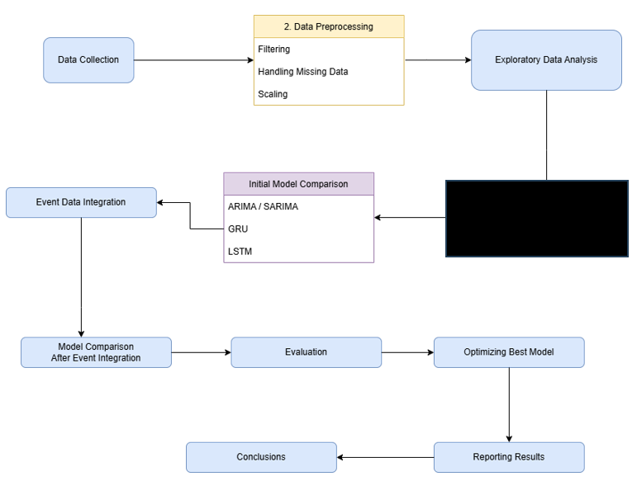
Fig 4.1 Methodology

1. Data Collection
The data for the companies under study was collected using the Yahoo Finance API. The data included stock prices of major Indian IT companies, namely Tata Consultancy Services, Infosys, Wipro, HCL Technologies, and Tech Mahindra. The historical stock data was fetched at a daily interval, spanning the entire duration for which Yahoo Finance provides data.
2. Data Preprocessing
The preprocessing phase involved several key steps to prepare the data for model training. First, the data was indexed by the date to ensure the time series structure. Any rows corresponding to the latest trading day were removed to ensure consistency in the dataset. Missing values due to holidays or non-trading days were filled using forward-fill techniques. Additionally, any gaps in the data were handled by resampling the dataset to ensure daily data points. The stock price data was then scaled using standard scaling to normalize the features. A new aggregated column was created to represent the combined performance of all stocks, which was later used as a target variable for prediction.
3. Exploratory Data Analysis (EDA)
The EDA phase aimed to understand the patterns and characteristics of the data, as well as identify relationships between the various features. Time series plots of the stock prices were created to visualize their trends over time. Additionally, daily returns were calculated and plotted as percentage changes to assess the volatility of each stock. A correlation matrix was generated to observe the relationships between the stock prices of different companies, gold prices, the USD/INR forex rate, and the S&P 500 index. Finally, a 30-day rolling volatility plot was constructed to assess the stability and risk associated with each stock. The purpose of EDA was to identify potential patterns, outliers, and trends in the data, and to inform the choice of model features.
4. Event Data Integration
For the purpose of improving model accuracy, external event data such as gold prices, the USD/INR forex rate, and the S&P 500 index were integrated into the stock data. These external factors could potentially influence stock prices. The data for these external variables was collected, and it was merged with the stock data using the date as a common key. Data consistency was ensured by filtering, filling missing values, and resampling where necessary.
5. Preparing and Training Models
ARIMA Model
The ARIMA model was employed to model the stock price data. Before applying ARIMA, stationarity of the data was checked using the Augmented Dickey-Fuller (ADF) test, with the p-value being used to assess the null hypothesis of non-stationarity. Auto-ARIMA was used to find the optimal set of parameters (p, d, q). The ARIMA model was trained, and predictions were made for the next 10 days. A line plot was used to compare the predicted values with the actual values for the last 10 days in the training dataset.
SARIMA Model
Similar to ARIMA, the SARIMA model was trained on the stock data after ensuring stationarity. Seasonal differences and lagged terms were incorporated to capture any seasonal trends in the data. The optimal parameters for the SARIMA model were determined, and the model was evaluated with predictions for the next 10 days.
GRU Model
For the GRU model, the data was first scaled using MinMax scaling to normalize the features. A sequence of past data points (60 days in this case) was used to predict future stock prices. The GRU model, which is an advanced version of Recurrent Neural Networks (RNNs), was then trained using this sequence of features, including stock prices and external event data. Early stopping was used to prevent overfitting, with the model being trained for 50 epochs. Once the model was trained, it was used to predict stock prices for the next 10 days, and the predictions were inverse-transformed back to their original scale.
LSTM Model
The LSTM model, another variant of RNN, was similarly trained to predict stock prices. The process was nearly identical to the GRU model, where the data was scaled, sequences were created, and the model was trained using 60-day windows of past data. Early stopping was implemented to prevent overfitting, and the LSTM model was trained over 50 epochs. The predictions made by the LSTM model were also inverse-transformed to get the actual stock prices.
6. Evaluation
The performance of each model was evaluated using two primary metrics: the R-squared (R²) score and the Mean Squared Error (MSE). The R² score provides a measure of how well the model explains the variance in the data, while the MSE indicates how closely the model's predictions align with the actual values. These metrics were computed for all models (ARIMA, SARIMA, GRU, and LSTM), and the models were compared based on their performance.
7. Optimizing Best Models
Optimization of the best-performing models involved fine-tuning the hyperparameters. For both ARIMA and SARIMA, parameter optimization was conducted by experimenting with different combinations of p, d, and q values. For the GRU and LSTM models, the learning rate, number of epochs, and batch size were adjusted to find the best configuration. Grid search and manual tuning were used to improve model accuracy, and the models were retrained with the optimized parameters.
8. Reporting Results
The results of the evaluation were compiled and compared across all models. It was observed that the RNN-based models (GRU and LSTM) outperformed the ARIMA and SARIMA models in terms of both R² and MSE. This was expected, as RNN models are better equipped to capture the complex, non-linear relationships present in time series data. The report includes visual comparisons of the model predictions versus actual values and discusses the implications of the results. The RNN models, particularly the GRU and LSTM, were found to provide the most accurate forecasts, which confirms their suitability for stock price prediction tasks.

- TOOLS AND TECHNIQUES
yfinance (Yahoo Finance API):
yfinance is a Python library that allows easy access to financial data from Yahoo Finance. It was used to download historical stock price data and other financial indicators required for the analysis. This tool enables convenient integration of time-series data into pandas DataFrames for further manipulation and analysis.
Statsmodels:
statsmodels is a Python library for statistical modeling. The ARIMA and adfuller functions from this package were used to check for stationarity in the time series and to fit ARIMA models. ARIMA is employed for univariate time-series forecasting, while the adfuller test is used to check the stationarity of the series through the Augmented Dickey-Fuller test.
pmdarima:
pmdarima is a Python package that simplifies the process of selecting ARIMA model parameters. The auto_arima function from this package was used to automatically select the best set of parameters (p, d, q) for ARIMA models, which helped optimize the forecasting model and improve prediction accuracy.
Matplotlib:
matplotlib is a plotting library for Python that was used to generate visualizations such as time-series plots, correlation matrices, and model predictions. These visualizations helped in performing exploratory data analysis (EDA) and in presenting results, such as the comparison of model predictions with actual data.
Scikit-learn:
Scikit-learn is a powerful machine learning library used for various tasks including data preprocessing and model evaluation. It provided tools for scaling data (StandardScaler), evaluating model performance (using metrics like MSE, MAE, and R²), and handling data transformations required during model building.
Keras (with TensorFlow backend):
Keras is a high-level neural networks API that runs on top of TensorFlow, used in this project to build and train deep learning models such as GRU (Gated Recurrent Units) and LSTM (Long Short-Term Memory) networks. These models were employed for time-series forecasting, capturing sequential dependencies in the data. The layers like GRU, LSTM, and Dense were used to define the model architecture.
TensorFlow:
TensorFlow is an open-source deep learning framework developed by Google, serving as the backend for the Keras models. It provides tools for building, training, and evaluating deep learning models, specifically for time-series forecasting in this project.
Keras Callbacks:
The EarlyStopping callback from Keras was used during model training to monitor validation loss and prevent overfitting. This allows the model to stop training once the validation performance stops improving for a specified number of epochs, ensuring efficient training.
Statsmodels API:
statsmodels.api was used for additional statistical modeling tasks. It provides tools for fitting models, including time-series analysis, and is widely utilized for statistical tests and model diagnostics, complementing the functions provided by statsmodels.tsa for ARIMA-based forecasting.

6 IMPLEMENTATION
6.1 About the Dataset
The Data was collected using the Yahoo Finance API.
- Source of the Dataset: Yahoo Finance API
- No. of Observations: 5951 per company
- Column/Feature Details: Date, Ticker, Open, Close, Adj Close, High, Low, Volume, APS, Gold Price, USD to INR, S&P 500
- Details about the columns:
  - Date: Discrete (time-series feature)
  - Price-related columns (Adj Close, Close, High, Low, Open): Continuous
  - Volume: Discrete (countable values)
6.2. Data Cleaning and Preprocessing
The preprocessing phase of this project was critical in preparing the stock market data for analysis and modeling. Data was sourced for five Indian IT sector companies listed on the Nifty 50 index using the Yahoo Finance API. Each dataset included key columns such as open, close, high, low, adjusted close, and volume. To enable efficient querying and analysis, a new “ticker” column was introduced, and both the “date” and “ticker” were used as indices. This indexing ensured that the data could be accessed conveniently, company-wise, and date-wise.
Data filtering involved removing rows corresponding to earlier dates for which some stocks lacked data. Maintaining uniformity in the dataset was crucial for consistent analysis, and discrepancies in date ranges across companies were resolved through this filtering process. While a check for missing values showed no null entries, this did not account for missing data in the true sense, as gaps in trading days (such as holidays) meant certain dates were entirely absent from the dataset. There were also cases where the trading volume was recorded as zero, indicating non-trading days. To address these issues, forward-filling techniques were employed to populate missing values, and the dataset was resampled to ensure daily continuity. This step was essential, particularly for time-series modeling methods such as ARIMA and SARIMA, which rely on consistent, uninterrupted data.
To prepare the data for ARIMA modeling, a new column called the Aggregate Performance Score (APS) was created. This column represented the combined performance of all five companies and served as the target variable for prediction. For convenience, a reduced dataset containing only the “date” and “APS” columns was extracted. Stationarity of this new dataset was tested using the Augmented Dickey-Fuller (ADF) test to ensure its suitability for ARIMA/SARIMA modeling. The stock price features were scaled using standard scaling to normalize the data, a step that improved the numerical stability of machine learning models. This scaling was extended to all relevant features, including external market indicators such as the gold price, USD-INR exchange rate, and S&P 500 index, which were later incorporated into the RNN models.
For the RNN-based models (GRU and LSTM), the dataset was aggregated further. Instead of retaining individual rows for each company, the dataset was transformed so that each date corresponded to a single row with aggregated values for columns such as open, close, high, low, and volume. This step ensured that the models could work on a unified dataset while preserving the time-series structure. Rescaled features and APS values were then combined into a single dataset, and sequences were created to capture temporal dependencies. The preprocessing phase thus laid a strong foundation for accurate modeling and forecasting.
6.3 Exploratory Data Analysis
Resnet50
Deep residual networks like the popular ResNet-50 model is a convolutional neural network (CNN) that is 50 layers deep. A residual neural network (ResNet) is an artificial neural network (ANN) of a kind that stacks residual blocks on top of each other to form a network. It can work with different input size and designed to overcome problem of vanishing gradient by using residual connections. 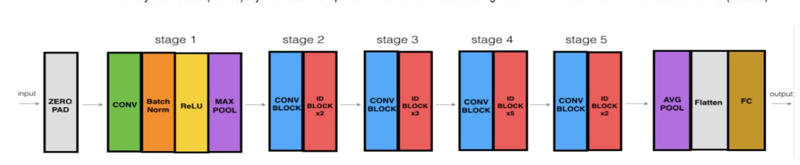
Fig 6.1 Architecture of Resnet50

- Architecture includes
  - It contains an initial convolutional layer, followed by a max pooling layer.
  - Four sets of convolutional layers, with each set containing several residual blocks.
  - A global average pooling layer.
  - A fully connected layer with a softmax activation function.
VGG16
- VGG Net is a Convolutional Neural Network architecture proposed by Karen Simonyan and Andrew Zisserman from the University of Oxford in 2014.
- Focuses on the effect of the convolutional neural network depth on its accuracy. The famous paper “Very Deep Convolutional Networks for Large-Scale Image Recognition” made the term deep viral. It was the first study that provided undeniable evidence that simply adding more layers increases the performance.
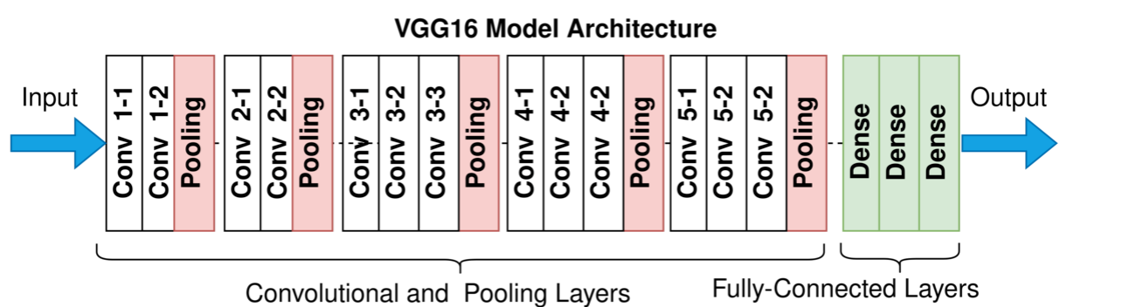
Fig 6.2 Architecture of VGG16

INCEPTION V3
- Inception-v3 is a pre-trained convolutional neural network that is 48 layers deep, which is a version of the network already trained on more than a million images from the ImageNet database. This pre-trained network can classify images into 1000 object categories, such as keyboard, mouse, pencil, and many animals.
- As a result, the network has learned rich feature representations for a wide range of images. The model extracts general features from input images in the first part and classifies them based on those features in the second part.
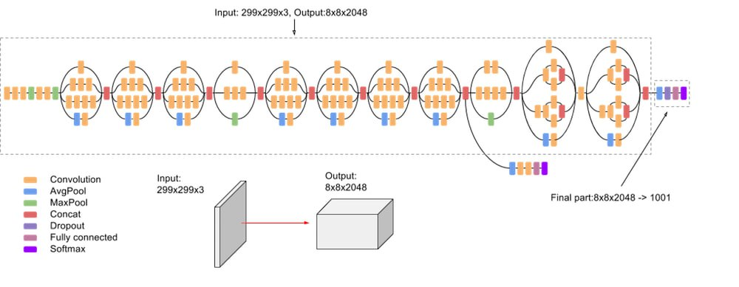
Fig 6.3 Architecture of Inception V3

DENSENET169
- DenseNet-169 was chosen because despite having a depth of 169 layers it is relatively low in parameters compared to other models, and the architecture handles the vanish gradient problem well.
- For each layer, the feature maps of all preceding layers are used as inputs, and its own feature-maps are used as inputs into all subsequent layers. DenseNet have several compelling advantages: they alleviate the vanishing-gradient problem, strengthen feature propagation, encourage feature reuse, and substantially reduce the number of parameters.
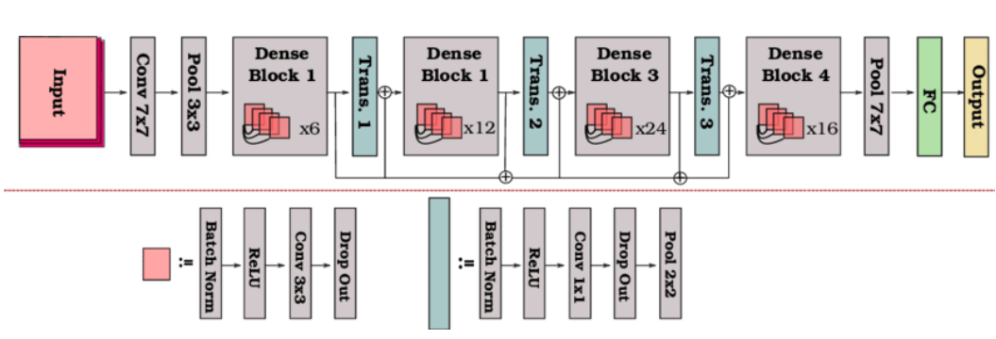
Fig 6.4 Architecture of Densenet169

6.4 Training Models and Predicting the future APS (Aggregate Performance Score)
The modeling phase involved three distinct approaches to forecast the future values of the Aggregate Performance Score (APS): ARIMA, SARIMA, and Recurrent Neural Networks (GRU and LSTM). Each method was tailored to capture different aspects of the time-series data.
ARIMA and SARIMA
For ARIMA modeling, the reduced dataset containing the “date” and “APS” columns was used. After verifying stationarity using the Augmented Dickey-Fuller test, the auto_arima function was employed to identify the optimal parameters (p, d, q) based on the Akaike Information Criterion (AIC). The best-fitting model was then trained, and a forecast for the next 10 days was generated. The predicted values were visualized on a line plot, comparing the last 10 observed days with the next 10 forecasted days, highlighting the model’s performance.
The SARIMA model extended this approach by incorporating seasonality into the analysis. Similar to ARIMA, auto_arima was used to determine the best seasonal parameters, and predictions were made for the same 10-day horizon. The results were again plotted to visualize the accuracy of the predictions in capturing seasonal trends.
GRU (Gated Recurrent Units)
To implement the GRU model, the fully aggregated dataset was used. This dataset contained scaled features for stock prices and external market indicators, as well as the scaled APS values. Temporal sequences were created using a sliding window approach, where each sequence consisted of 60 time steps corresponding to 60 days of historical data. The sequences were divided into input features (X) and target values (y). The data was then split into training and testing sets, with the latter constituting 20% of the data.
A GRU-based neural network was constructed with a single GRU layer containing 64 units, followed by a dense output layer with one unit to predict the APS value. The model was compiled using the Adam optimizer and a mean squared error loss function. Early stopping was implemented with a patience of five epochs to prevent overfitting and ensure that the model’s weights were restored to the best-performing state. The training process involved 50 epochs and a batch size of 32.
Once the GRU model was trained, the last 60-day sequence from the test dataset was used as input to predict APS values for the next 10 days. Predictions were generated iteratively, with each new prediction incorporated back into the sequence for subsequent forecasts. The predicted values were then inverse-transformed to obtain the actual APS values. Finally, a line plot was created to compare the last 10 observed days with the next 10 predicted days, illustrating the model’s forecasting ability.
LSTM (Long Short-Term Memory)
The LSTM model followed a similar process to the GRU model. The same aggregated dataset and scaled features were used to create temporal sequences. An LSTM-based neural network was designed with one LSTM layer containing 64 units, followed by a dense output layer with one unit. The model was compiled with the Adam optimizer and a mean squared error loss function. Early stopping was again utilized to enhance training efficiency and prevent overfitting.
After training the LSTM model using 50 epochs and a batch size of 32, predictions were made for the next 10 days using the last 60-day sequence from the test dataset. The iterative prediction approach was similar to the GRU implementation. Predicted APS values were inverse-transformed to their original scale and plotted alongside the last 10 observed days to visualize the forecast accuracy.
Both the GRU and LSTM models demonstrated the ability to capture complex patterns in the time-series data, with early stopping ensuring that the models generalized well to unseen data. The visual comparison of past and future APS values provided a clear assessment of the models’ performance.

6.5 Evaluation
ARIMA
The ARIMA model was evaluated by splitting the dataset into training and testing sets using an 80-20 split. The model was trained on the first 80% of the data, and predictions were made for the remaining 20%. Evaluation metrics included Mean Squared Error (MSE) and R-squared. The ARIMA model produced an MSE of 42199.93, indicating a substantial error in predictions. Furthermore, the R-squared value was -0.198, signifying that the model failed to capture the variance in the data and performed worse than a simple mean-based prediction.
SARIMA
Similar to ARIMA, the SARIMA model was trained and tested on an 80-20 split of the data. Seasonal parameters were optimized using an automated search. The model achieved an MSE of 75829.18, which is higher than ARIMA, suggesting less accurate predictions. The R-squared value of -1.153 highlights a severe underperformance, where the model failed to explain the variance in the testing data, likely due to overfitting or improper seasonal adjustments.
GRU
The GRU model utilized scaled input features and the APS target variable to predict stock prices. Data was split into training and testing sets, with sequences of 60 time steps used as input. The model was trained with early stopping to prevent overfitting. Evaluation metrics included MSE, RMSE, MAE, MAPE, and R-squared. The GRU model achieved an MSE of 18856.15, significantly lower than ARIMA and SARIMA, demonstrating more accurate predictions. The R-squared value of 0.467 indicates that the GRU model explained nearly half of the variance in the data, outperforming the traditional statistical models.
LSTM
The LSTM model followed a similar process to the GRU, using scaled data and sequential inputs of 60 time steps. Evaluation metrics were consistent with those used for GRU. The LSTM model achieved an MSE of 20845.28, slightly higher than the GRU model but still considerably lower than ARIMA and SARIMA. The R-squared value was 0.403, reflecting that the LSTM model captured a significant portion of the variance in the data, albeit less effectively than the GRU model.

7. RESULTS AND DISCUSSIONS
The evaluation of ARIMA, SARIMA, GRU, and LSTM models revealed distinct performance differences in predicting stock market trends. The results, summarized in Table 1, indicate that deep learning models, particularly GRU and LSTM, outperformed traditional statistical methods like ARIMA and SARIMA. GRU achieved the highest R-squared value of 0.468 and the lowest Mean Squared Error (MSE) of 18,856.15, followed closely by LSTM with an R-squared of 0.403 and an MSE of 20,845.28. In contrast, ARIMA and SARIMA demonstrated poor predictive capabilities, with negative R-squared values and significantly higher MSEs, at 42,199.93 and 75,829.18, respectively.
Model | R-squared | Mean Squared Error
ARIMA | -0.19 | 42199.93
SARIMA | -1.15 | 75829.18
GRU | 0.468 | 18856.15
LSTM | 0.403 | 20845.28

These findings highlight the limitations of ARIMA and SARIMA in capturing the non-linear dynamics inherent in stock market data, which is better modeled by deep learning techniques. GRU’s superior performance can be attributed to its architecture, which effectively mitigates the vanishing gradient problem and excels in learning temporal dependencies from data. The observed patterns align with expectations, as the complex, non-linear nature of financial data is inherently more suitable for neural network-based models.

Comparing these results with related literature, while direct comparisons are limited by differences in datasets and methodologies, similar trends emerge. Studies consistently demonstrate the outperformance of deep learning models, such as LSTM and GRU, over traditional statistical methods. For instance, LSTM models in the literature achieved low RMSEs across diverse financial datasets. However, the slight underperformance of LSTM in this study relative to GRU suggests the need for further tuning of hyperparameters or enhancements in feature engineering to fully leverage its potential. Overall, this study reaffirms the growing consensus on the efficacy of deep learning techniques for stock market forecasting.

8. CONCLUSION
This study highlights the capabilities and limitations of different predictive models in the context of stock market forecasting. Deep learning models such as GRU and LSTM proved to be more effective than traditional statistical methods like ARIMA and SARIMA, which struggled with the non-linear and volatile nature of stock price data. The success of GRU and LSTM underscores the importance of capturing temporal dependencies and complex patterns inherent in financial datasets. These models' ability to learn and adapt to intricate relationships within data marks a significant step forward for predictive analytics in finance.
At the core of these findings is the adaptability of neural networks in handling dynamic and unpredictable data, a task where statistical models falter. However, the results also reveal limitations, particularly in the context of scalability, hyperparameter tuning, and data requirements for deep learning models. These aspects highlight the need for further refinement and exploration to unlock their full potential.
The broader implications of this research extend to both academic and practical domains. By leveraging advanced machine learning techniques, stakeholders can develop more reliable tools for forecasting and risk management, ultimately aiding in investment decision-making. However, this work also serves as a reminder of the inherent uncertainties in financial markets, which no model can fully eliminate. Future efforts should focus on integrating external factors, such as economic indicators and news sentiment, into predictive frameworks to improve their robustness and applicability in real-world scenarios.

9. FUTURE ENHANCEMENT
Future work will focus on improving data preprocessing by exploring advanced techniques for handling missing values, such as imputation strategies that preserve data integrity. Building on the promising performance of GRU and LSTM, I plan to fine-tune their hyperparameters to optimize predictive accuracy further. Inspired by insights from related research, hybridizing GRU and LSTM models could leverage their complementary strengths, addressing challenges in capturing both short-term dependencies and long-term trends. Additionally, incorporating sentiment-driven analysis into the framework offers a compelling direction, as market sentiment often provides richer contextual signals for stock price movements compared to purely numerical data.

10.APPENDICIES
10.1 FULL CODE

SCREENSHOTS:
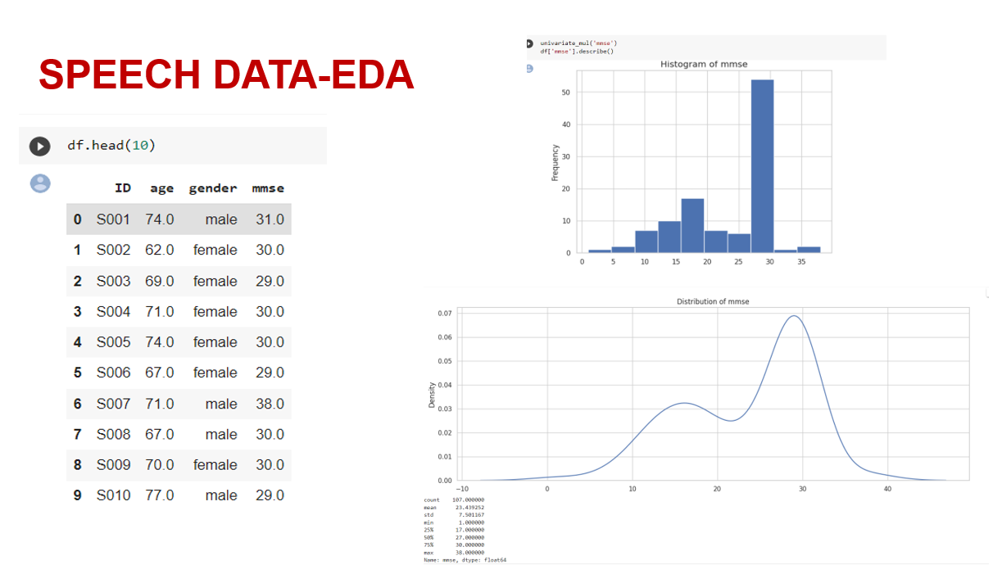
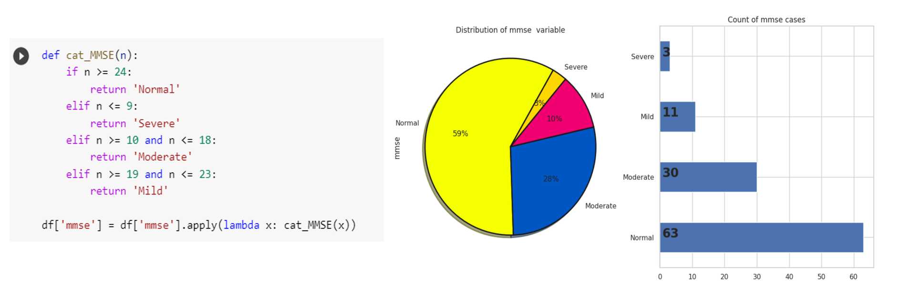
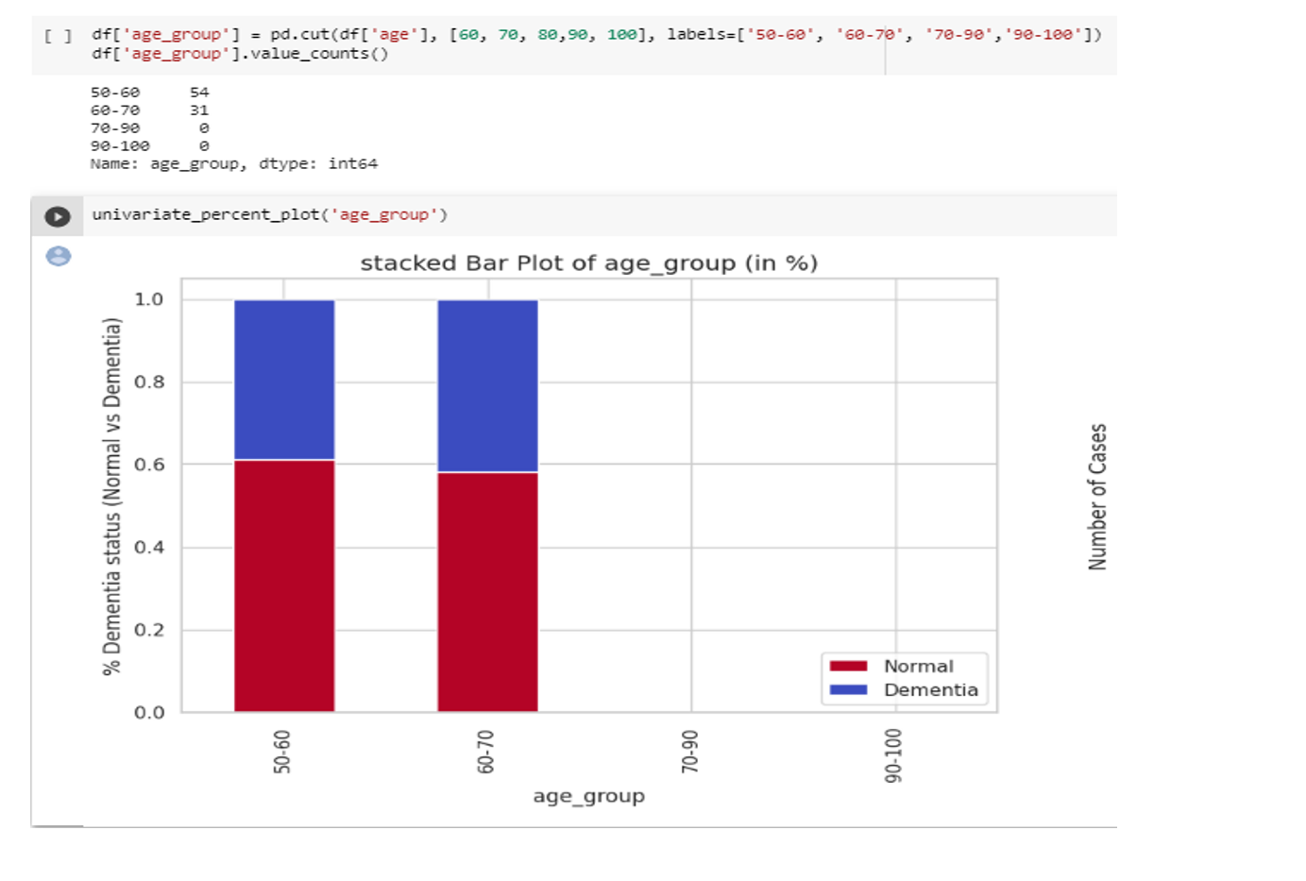
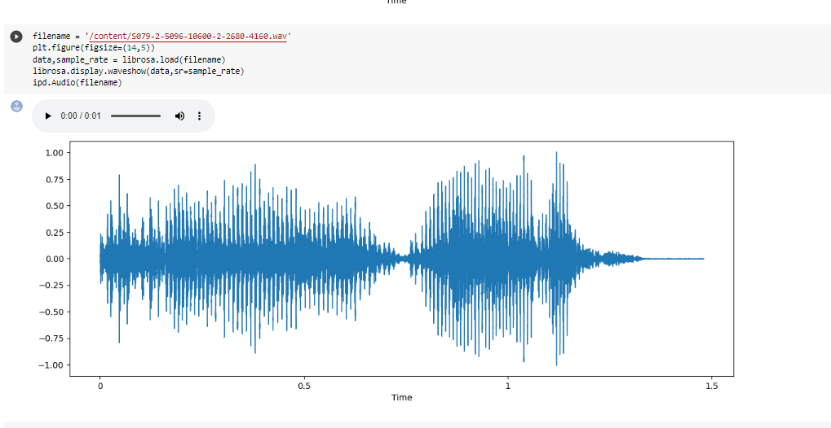
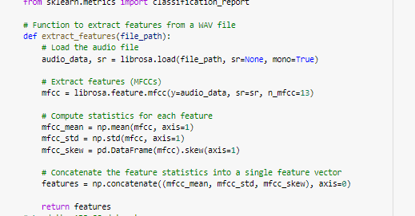
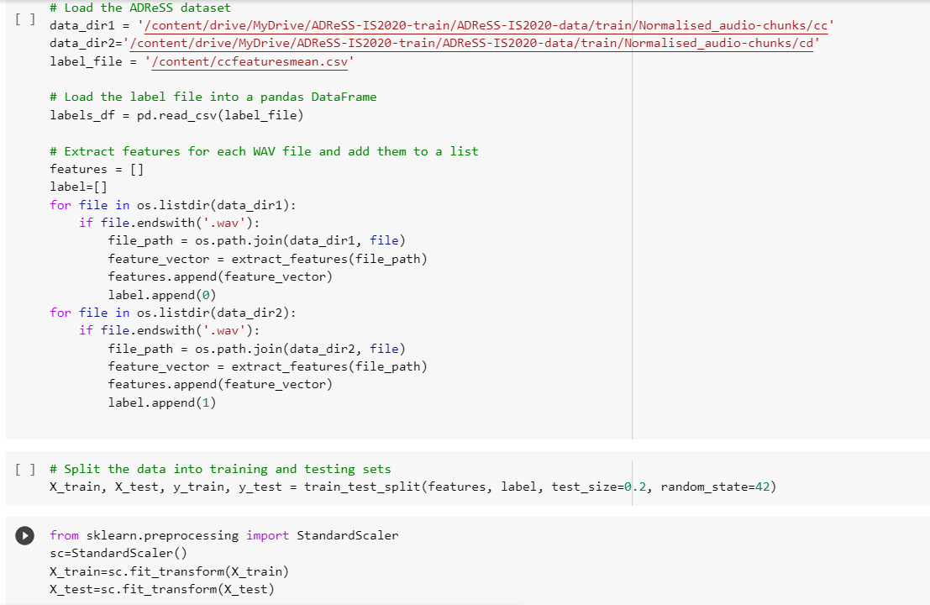
DECISION TREE:
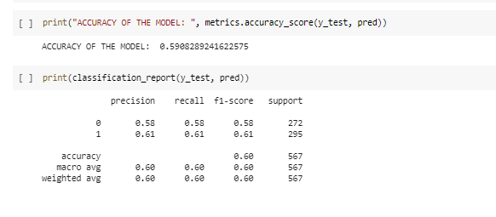
RANDOM FOREST:
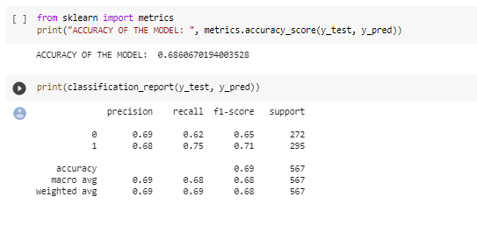
SUPPORT VECTOR CLASSIFICATION:
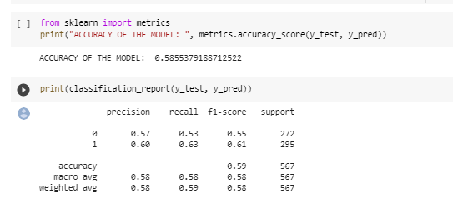
NAÏVE BAYES:
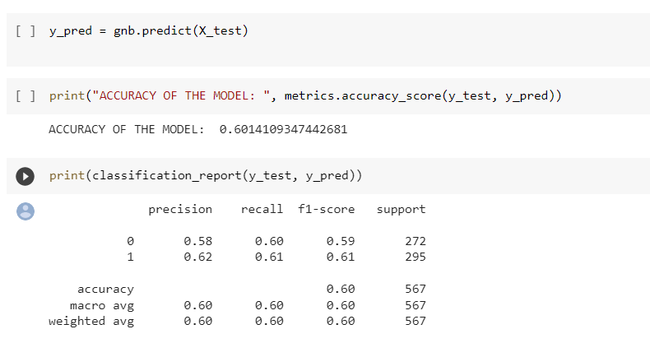
KNN:
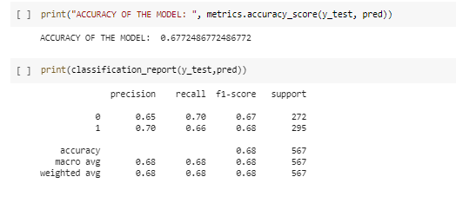
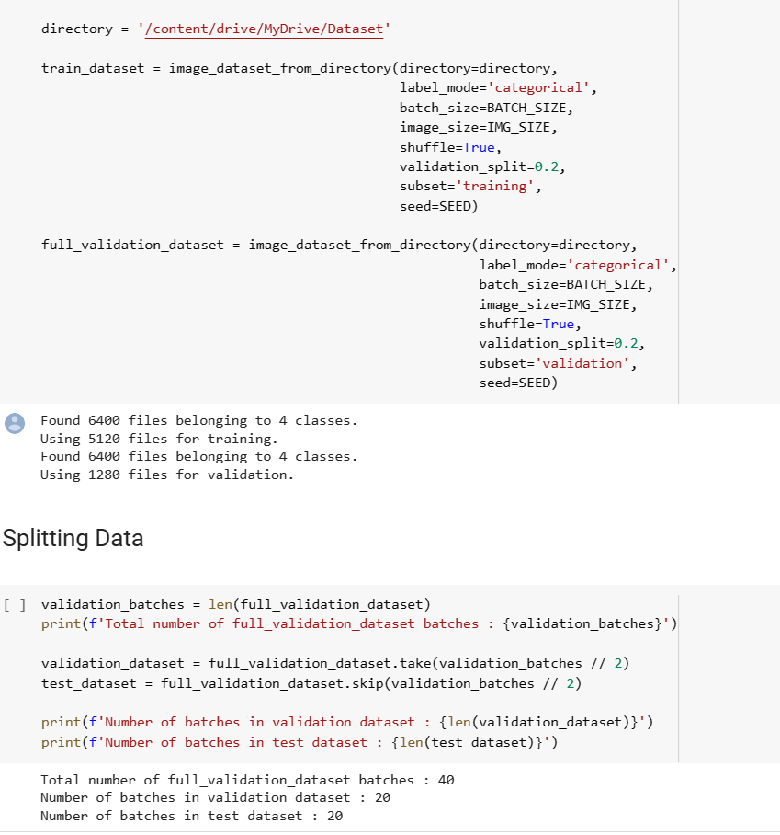

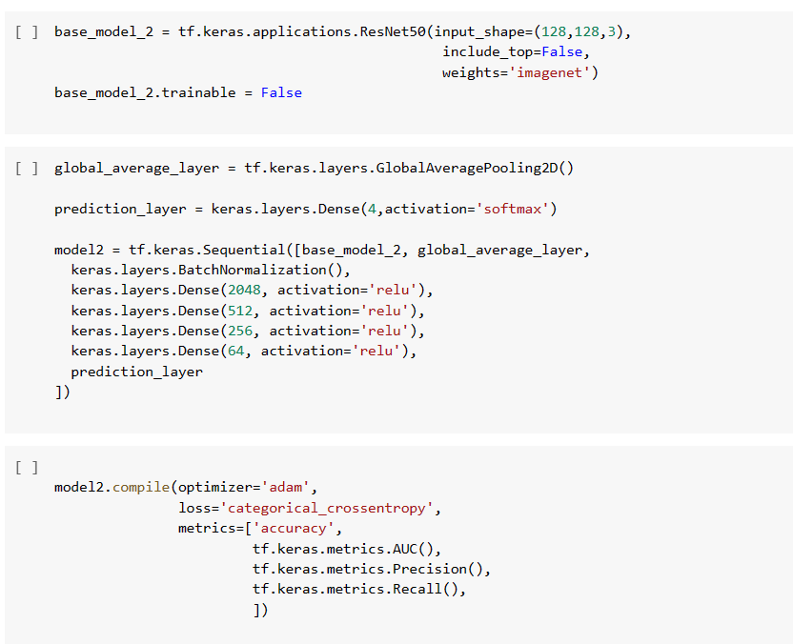

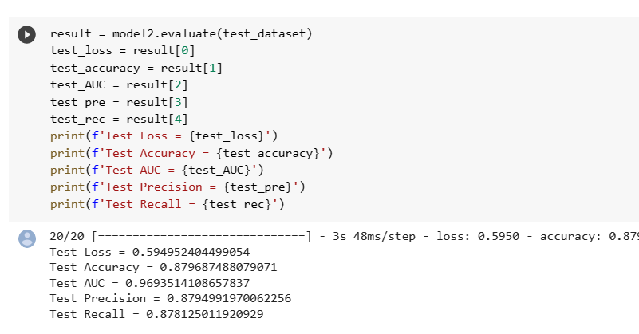

10.2 PLAGIARISM REPORT

11. REFERENCES
Journal References (APA FORMAT):
[1] Sharma, S., Gupta, S., Gupta, D., Altameem, A., Saudagar, A. K. J., Poonia, R. C., & Nayak, S. R. (2022). HTLML: Hybrid AI Based Model for Detection of Alzheimer’s Disease. Diagnostics, 12(8), 1833
[2] Haulcy, R'mani, and James Glass. "Classifying Alzheimer's disease using audio and text-based representations of speech." Frontiers in Psychology 11 (2021): 624137.
[3] Luz, S., Haider, F., de la Fuente, S., Fromm, D., & MacWhinney, B. (2020). Alzheimer's dementia recognition through spontaneous speech: The ADReSS challenge. arXiv preprint arXiv:2004.06833.
Web References:
1.MFCC extraction technique: MFCC Technique for Speech Recognition - Analytics Vidhya
2.Alzheimer classification using image: https://devpost.com/software/classification-of-alzheimer-s-disease-from-speech-data
3.Performance evaluation in deep learning: Performance Evaluation of Deep Learning Algorithms in Biomedical Document Classification | IEEE Conference Publication | IEEE Xplore
4.Preprocessing techniques for medical data: Medical Image Pre-Processing with Python | by Esma Sert | Towards Data Science

12.WORKLOG
ATTACH THE WORKLOG SHEET DULY SIGNED EACH DAY BY THE STUDENT AND GUIDE
Day | Date | Task Done
Day 1 | 15/02/2023 | Project domain discussion
Day 2 | 16/02/2023 | Domain Research
Day 3 | 17/02/2023 | Domain Research
Day 4 | 20/02/2023 | Domain Research
Day 5 | 21/02/2023 | Project title finalization
Day 6 | 22/02/2023 | Collecting Study materials
Day 7 | 23/02/2023 | Collecting Study materials
Day 8 | 24/02/2023 | Going through research journals
Day 9 | 27/02/2023 | Going through research journals
Day 10 | 28/02/2023 | Going through research journals
Day 11 | 1/03/2023 | Discussion project architecture
Day 12 | 2/03/2023 | Discussion project architecture
Day 13 | 3/03/2023 | Collecting Speech Dataset
Day 14 | 6/03/2023 | Collecting Image Dataset
Day 15 | 7/03/2023 | Analyzing the Dataset available
Day 16 | 8/03/2023 | Pre-processing the image dataset
Day 17 | 9/03/2023 | Pre-processing the image dataset
Day 18 | 10/03/2023 | Pre-processing the image dataset
Day 19 | 13/03/2023 | Working on Data Augmentation Techniques
Day 20 | 14/03/2023 | Working on Data Augmentation Techniques
Day 21 | 15/03/2023 | Model 1
Day 22 | 16/03/2023 | Model 2
Day 23 | 17/03/2023 | Model 3
Day 24 | 20/03/2023 | Model 4
Day 25 | 21/03/2023 | Working on getting better accuracy
Day 26 | 22/03/2023 | Working on getting better accuracy
Day 27 | 23/03/2023 | Prediction using the model
Day 28 | 24/03/2023 | Completed deep learning models for Image Dataset
Day 29 | 27/03/2023 | Analysing the speech dataset
Day 30 | 28/03/2023 | Finalizing the approach for speech data
Day 31 | 29/03/2023 | Exploratory data analysis using speech data
Day 32 | 30/03/2023 | Exploratory data analysis using speech data
Day 33 | 31/03/2023 | Exploratory data analysis using speech data
Day 34 | 03/04/2023 | Feature extraction
Day 35 | 04/04/2023 | Feature extraction
Day 36 | 5/04/2023 | Feature extraction
Day 37 | 6/04/2023 | Pre-processing the data
Day 38 | 6/04/2023 | Pre-processing the data
Day 39 | 7/04/2023 | Determine what models to utilize
Day 40 | 10/04/2023 | Model Building
Day 41 | 11/04/2023 | Model Building
Day 42 | 12/04/2023 | Model Building
Day 43 | 13/04/2023 | Comparing the models for best results
Day 44 | 14/04/2023 | Completed the classification using Speech data
Day 45 | 17/04/2023 | Working on final review presentation
Day 46 | 18/04/2023 | Working on final review presentation
Day 47 | 19/04/2023 | Working on final review presentation
Day 48 | 20/04/2023 | Working on Report
Day 49 | 21/04/2023 | Working on Report
Day 50 | 24/04/2023 | Working on Report

